The [*Mail User Agent*](gloss01.html#gloss_240), or MUA for short, is the technical term for an email client. You use your MUA to send and receive email. Many things can do the job of the MUA such as a dedicated program, a web page, a smartphone, or even an application that sends out alerts.

The MUA’s job is to capture the email in some format, including the recipient, and send it to the next link in the email chain—the[*Mail Transfer Agent (MTA)*](gloss01.html#gloss_239).

The [MUA](gloss01.html#gloss_255) is free to communicate to the [MTA](gloss01.html#gloss_254) in whatever protocol makes sense. Where the email system is a proprietary one such as Microsoft Exchange using Microsoft Outlook as the MUA, the communication is done in some kind of application-specific protocol. The MUA might be an application running inside a browser, so the communication there might be called to a remote web server. Other times the communication is done in the protocol used to transfer mail over the Internet itself: the [*Simple Mail Transfer Protocol (SMTP)*](gloss01.html#gloss_386).

Linux comes with various GUI based email client to stay in touch with your friends and family, and share information in newsgroups with other users. The following software is similar to Outlook Express or Windows Live Mail and is used by both home and office user.

Webmail interfaces allow users to access their mail with any standard web browser, from any computer, rather than relying on an e-mail client.

[http://c.cyberciti.biz/cbzcache/3rdparty/download_of_the.day.png](http://www.cyberciti.biz/tips/category/download-of-the-day)

However, [e-mail client](http://en.wikipedia.org/wiki/E-mail_client) remains extremely popular in a large corporate environment, small business, home and power users. An e-mail client (also mail user agent (MUA)) is a frontend computer program used to manage e-mail. Mail can be stored on the client, on the server side, or in both places. Standard formats for mailboxes include Maildir and mbox.

The following are top five amazing piece of cross-platform software from various projects to make your life easy with wide variety of plug-ins / add-ons.

**#1: Mozilla Thunderbird**

It is an e-mail and news cross-platform client software package by Mozilla Foundation. Thunderbird can manage multiple e-mail, newsgroup and RSS accounts and supports multiple identities within accounts. Features like quick search, saved search folders , advanced message filtering, message grouping, and labels help manage and find messages. Just like Firefox, the tons of extensions and themes for this client makes it very secure and flexible to to enhance your productivity.

[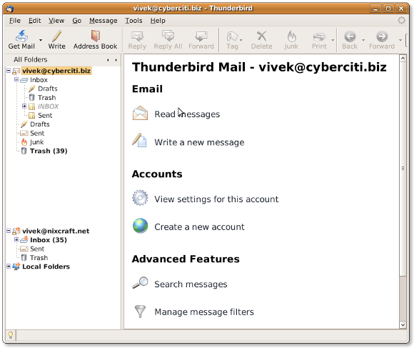](http://www.cyberciti.biz/tips/download-email-client-for-linux-mac-osx-windows.html/thunderbird)

Fig.01: Mozilla Thunderbird

=> [Download Mozilla Thunderbird](http://www.mozillamessaging.com/en-US/)

**#2: Claws Mail**

Claws Mail is a free, GTK+-based, open source email and news client. It is very light lightweight. Like Firefox , the wide variety of plug-ins for this email client makes it very flexible and secure. Claws Mail runs on Windows, Mac OS X and Unix-like systems such as Linux, BSD, and Solaris.

[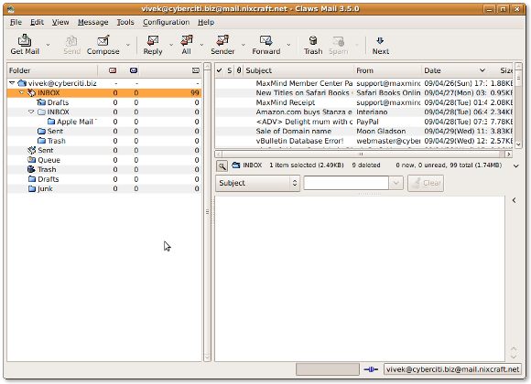](http://www.cyberciti.biz/tips/download-email-client-for-linux-mac-osx-windows.html/claws-mail-3-5-0)

Fig.02: Claws Mail in Action

=> [Download Claws Mail](http://www.claws-mail.org/)

**#3: Spicebird**

**Update: Ed – 23/June/2010** ~ *Spicebird client is* ***no longer supported on Mac OS X****. We will replace this email client with another supported product shortly.*

Spicebird is a collaboration client that provides integrated access to email, contacts, calendaring and instant messaging in a single application. It provides easy access to various web services while retaining all the advantages of a desktop application. It is developed by an Indian company called Synovel. It is a free, open source and cross-platform software.

[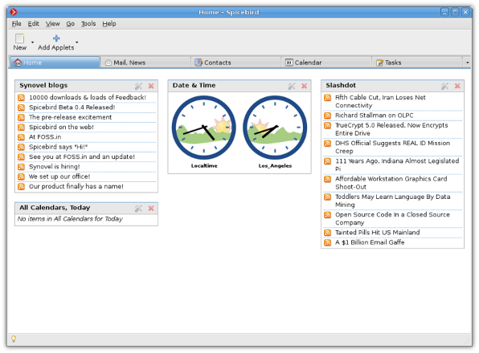](http://www.cyberciti.biz/tips/download-email-client-for-linux-mac-osx-windows.html/spicebird)

Fig.03: Spicebird in Action (image credit Spicebird project)

=> [Download Spicebird](http://www.spicebird.com/)

**#4: Zimbra Collaboration Suite (Open Source Version)**

Zimbra is a client and server platform for messaging and collaboration. The web client integrates email, contacts, shared calendar, VoIP, and online document authoring in a rich browser-based interface. This is more like MS-Exchange and Outlook combo. In other words it is compatible with proprietary clients such as Microsoft Outlook and Apple Mail, both through proprietary connectors, as well as the open-source Novell Evolution, so that mail, contacts, and calendar items can be synchronised from these to the ZCS server. Zimbra also provides native two-way sync to many mobile devices such as Nokia Eseries, BlackBerry, Windows Mobile, iPhone with 2.0 software.

[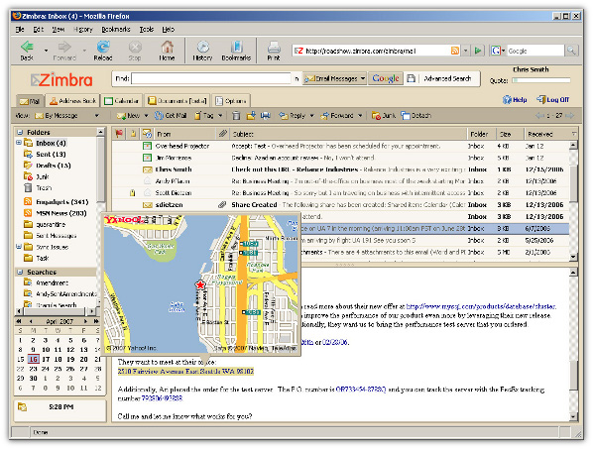](http://www.cyberciti.biz/tips/download-email-client-for-linux-mac-osx-windows.html/zimbra)

Fig.04: Zimbra (credit offical Zimbra website)

=> [Download Zimbra Collaboration Suite (Open Source Version)](http://www.zimbra.com/community/downloads.html)

**#5: Sylpheed**

Sylpheed is a free, GTK+-based, open source email and news client. It is very light lightweight. Sylpheed runs on Windows, Mac OS X and Unix-like systems such as Linux, and BSD.

[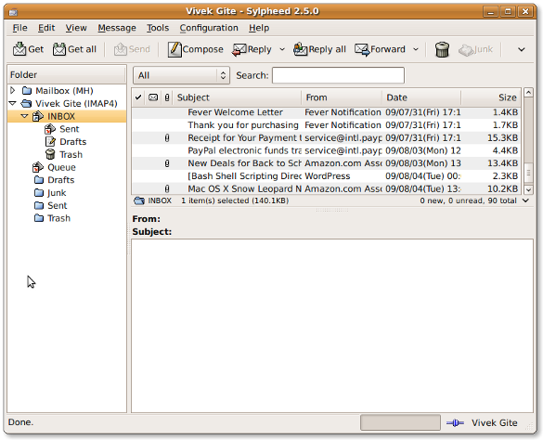](http://www.cyberciti.biz/tips/download-email-client-for-linux-mac-osx-windows.html/sylpheed)

Fig.05: Sylpheed in Action

=> [Download sylpheed](http://sylpheed.sraoss.jp/en/)

**Comparison of E-mail Clients – Essential Features**

The following tables compare general and technical information between e-mail client programs.

|  |  |  |  |  |  |
| --- | --- | --- | --- | --- | --- |
| **Feature** | **Thunderbird** | **Claws Mail** | **Spicebird** | **Zimbra** | **Sylpheed** |
| Cross-platform | Y | Y | Y | Y | Y |
| License | [MPL](http://en.wikipedia.org/wiki/Mozilla_Public_License), MPL/GNU [GPL/GNU](http://en.wikipedia.org/wiki/GNU_General_Public_License) [LGPL](http://en.wikipedia.org/wiki/GNU_Lesser_General_Public_License) | GPL | MPL, MPL/GNU GPL/GNU LGPL | MPL (server) and [ZPL](http://en.wikipedia.org/wiki/Zope_Public_License) (client) | GPL/LGPL |
| Cost | Free | Free | Free | Free | Free |
| Authentication | Y | Y | Y | Y | Y |
| SSL and TLS | Y | Y | Y | Y | Y |
| Image blocking | Y | Y | Y | Y | Y |
| Junk filtering | Y | Y | Y | Y | Y |
| Phishing filtering | Y | Y | Y | Y | ? |
| Add-ons | Y | Y | Y | ? | N |
| Thread view | Y | Y | Y | Y | Y |
| PGP support | Y | Y | Y | ? | Y |
| Label Messages | Y | Y | ? | Y | Y |
| Spell Checking | Y | Y | ? | Y | N |
| Signatures | Y | Y | Y | Y | Y |
| Scheduled message | Y | ? | ? | ? | ? |
| Message templates | Y | Y | ? | Y | Y |
| Database | [mbox](http://en.wikipedia.org/wiki/Mbox) | [MH](http://en.wikipedia.org/wiki/MH_Message_Handling_System), [mbox](http://en.wikipedia.org/wiki/Mbox) | ? | File system | [MH](http://en.wikipedia.org/wiki/MH_Message_Handling_System) |
| POP3 | Y | Y | Y | Y | Y |
| IMAP4 | Y | Y | Y | Y | Y |
| SMTP | Y | Y | Y | Y | Y |
| NNTP (News) | Y | Y | Y | Y | Y |
| RSS Feed | Y | Y | Y | Y | N |
| LDAP | Y | Y | Y | Y | N |
| iCalendar | Y | ? | Y | Y | N |
| Paid Support | ? | ? | ? | ? | Y |

Y = supported; N = not supported; ? = unknown; Privacy feature; Security features; Productivity features; Cross-platform – runs on Mac OS X, Windows and UNIX like operating systems.

**Other Email Clients For UNIX Like Operating Systems**

1. [SeaMonkey](http://www.seamonkey-project.org/) – Mozilla SeaMonkey is an all-in-one Internet application suite that includes an Internet browser, email and newsgroup client, HTML editor, IRC chat, and web development tools. It includes a pop-up blocker, junk mail controls, and a tabbed interface.
2. [Pine (Alpine)](http://www.washington.edu/alpine/) – Alpine is a rewrite of the Pine Message System that adds support for Unicode and other features. Alpine is meant to be suitable for both inexperienced email users and the most demanding of power users.
3. [Evolution or Novell Evolution](http://projects.gnome.org/evolution/) – Evolution provides integrated mail, addressbook and calendaring functionality to users of the GNOME desktop.

**Our Recommendations:**

1. **Claws Mail** – Highly recommended for netbook user due to lightweight usage.
2. **Mozilla Thunderbird** – The wide variety of add-on for this email client makes it very flexible, secure and easy to use. Highly recommended for desktop and power users.
3. **Zimbra Collaboration Suite** ~ Open Source Edition or Businesses Editon – Highly recommended for business and corporate users due to its support for a broad range of email clients and mobile devices via “over the air” sync.